FMX Mobile Application Development

**Lab Exercise 02.03: Creating & Connecting to a database**

## Creating the Database

In this training, you use the **EMBEDDEDIBLITE** database. Follow the steps below to create that database:

1. Log on to the server as the Username of your choice
2. Select **Database > Create Database**.

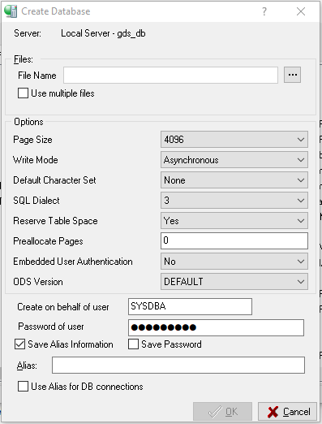

1. Enter **EmbeddedIBLite** in the **Alias** field.
2. Use the **...** button to browse to the location for the database or enter the location into the **File Name** field.
3. **Note:** In this training, we use the C:\Data\embeddediblite.ib location. You can use another location if you wish.
4. Use **EmbeddedIBLite.ib** as the file name.

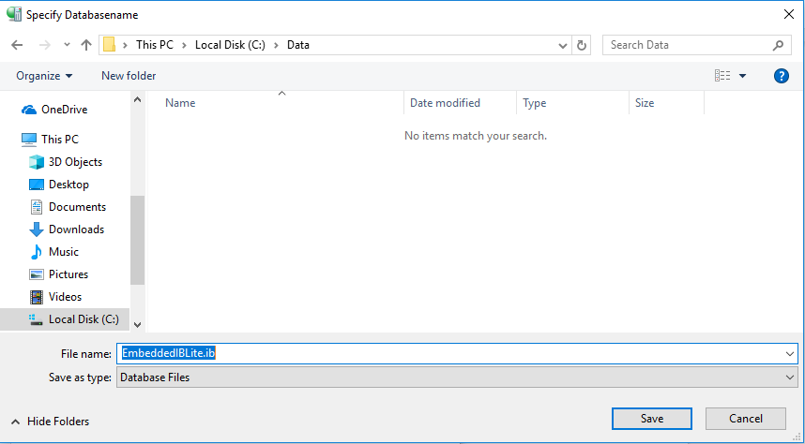

## Connecting to the EmbeddedIBLite Database

To connect to the database, follow these steps:

1. Select the EmbeddedIBLite database in the left pane of IBConsole.
2. Choose **Database > Connect**.

**Note:** The **Database Connect** dialog opens automatically when you create the **IBLite** database.

1. Enter the password for the user you are using.
2. Use **Connect**.

**Note:** Use the **Save Settings** check box to save the credentials for the next time that you connect to this database. In order to connect as a different user, choose **Database > Connect As**.

1. The status bar displays the name of the connected user, in this case: **SYSDBA**

